1) Key concepts:
- List and briefly define three key concepts of modern frontend frameworks, such as component-based design, client-side rendering, and declarative programming.

Component-based design: is small, independent, reusable code blocks used in the building of user interface or application, making it easy to scale, troubleshoot etc.
Client-side rendering: is rendering process happens on the user end browser. The process involves javascript execution behind the html codes that dynamically changes the UI using DOM manipulation without connecting to the server for a full page reload. Thus is faster.
Declarative programming: is framework that defines the end state of your code program or UI. Making codes easer to develop , maintain and understand.

- For each concept, provide a short example or scenario where it would be beneficial in a real-world application.
Component-based design eg: Amazon online ecommerce website. The main homepage has product-card component used in multiple other pages. The product-card component has its own structure and if there are changes needed in the styling, just have to edit in a single css file.
Client-side rendering eg: A web-based application that allows user to locally sort items in order, filtering options, adding and removing items in a cart. Behind the scene, this is done at the client’s browser without sending requests to the server for full html page reload.
Declarative programming eg: In a web-based form, if there is a button to trigger a condition, and show a new field or item in the browser, behind the scene in the code, the developer actually defines the target state of the trigger button by calling the component/function.

2) Component Creation and Reusability
a) Using CodeSandbox, create two reusable components, such as a Button and a Card.
b) Demonstrate how each component can be reused within different parts of a simple web page. For instance, use the Button in multiple sections to trigger different actions, or display the Card component with different content.
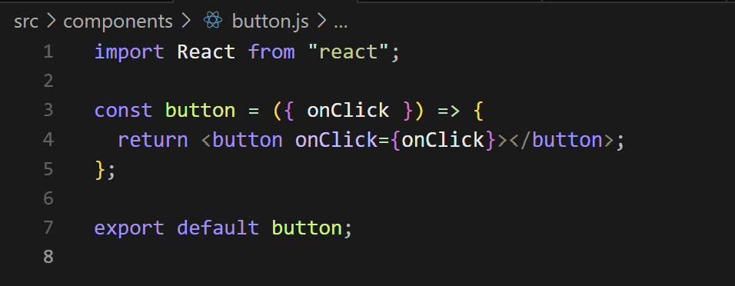
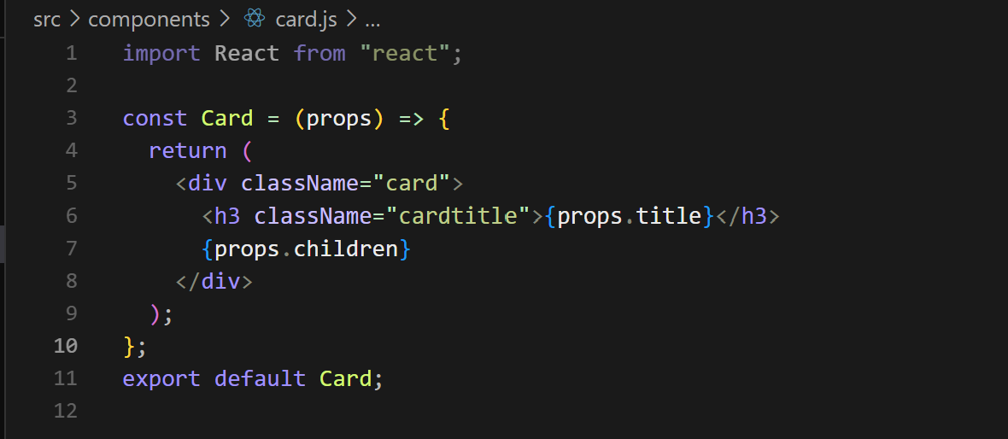
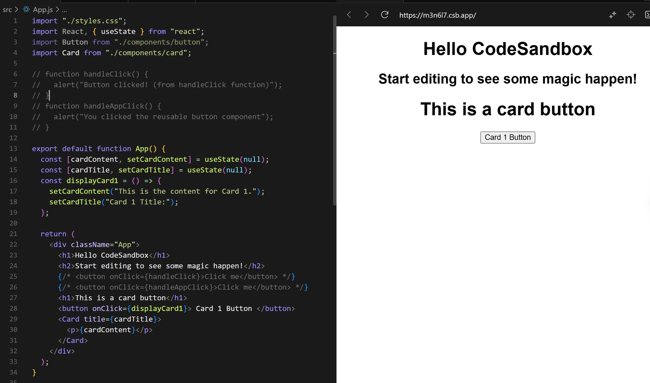
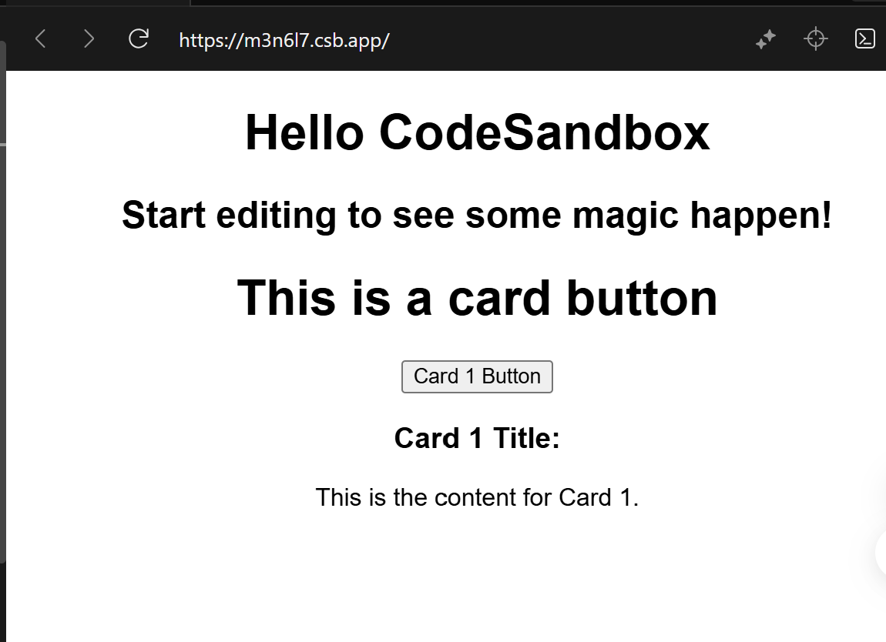

3. CSR & SSR
a) Explain CSR & SSR
CSR: Client side rendering is a rendering process happened on users’ browser or interface
SSR: Server side rendering is rendering the html content at the server before sending to users’ browser
b)Difference between CSR and SSR with advantages
CSR advantage: items in the html page loads faster thus enhancing the user experience. Reducing network traffic costs to server.
SSR advantage: helps with SEO , search engines crawl and index the html content easily.

4. Single Page Application (SPA) Structure
a) Define SPA
SPA is single page web application html, that dynamically loads or updates the contents using javascript, without requiring a full page reload from the server.
b) List two advantages of SPA structure for modern web applications
SPA advantages: 1) faster user experience, no need for full html reload from server, so less network bandwidth needed. 2) modularised architecture, easier to scale and less code complexity.

